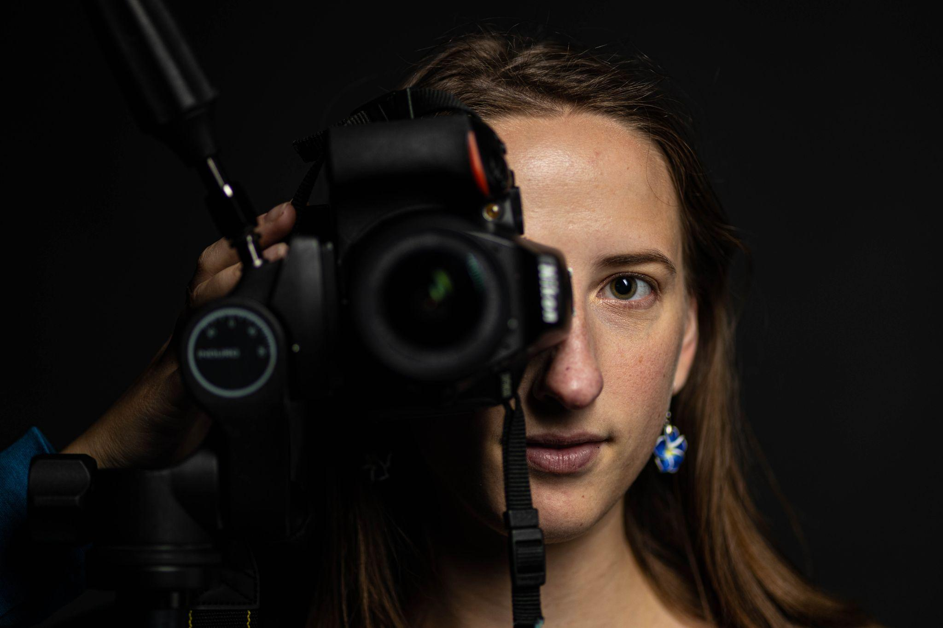

Shutterbird Photo Art

Booking Form

Today’s Date___________________________

Name__________________________________

Email __________________________________

Phone _________________________________

Address_________________________________________________________________

Photo Session type______________________________

Dates and times in mind for session

___________________________________

___________________________________

___________________________________

___________________________________

Session

Indoor Outdoor

Payment Plan

Half or full payment on day of session

*2nd half once you’ve received the photos*

Check / Cash / Zelle